RMIT LSS 2015
“THE HOODIE”

PLEASE RETURN with PAYMENT by 24 April 2015
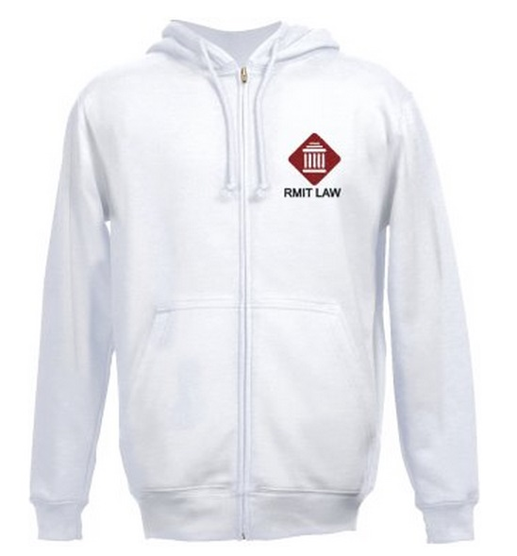
RMIT LSS is pleased to offer this exclusive RMIT LAW hoodie for the very low price of $45.

The Hoodie is a zip up white hoodie with an embroidered logo.
“Heavy blend adult full zip hooded sweatshirt approx. 220g, 50/50 cotton/polyester fleece. Pouch pockets and set-in sleeves.”

Please order by 24 April, with delivery EXPECTED to be before mid-May.
We will email your student account when you can come and collect your hoodie.

NAME:____________________________________

STUDENT NO:______________________________

Size: ___________

TOTAL: $45_

Size | S | M | L | XL | 2XL
Chest Width cm | 48 | 53 | 58 | 64 | 69

***Width measurement is the size of the hoodie from under arm to under arm.
**** Please note all hoodies are in U.S. sizes and may run large.

❑ PayPal
Payment sent to president@rmitlss.com and marked with your student number

❑ Bank Deposit
BSB: 063 262
Account: 10479240
Name: LSS

Payment marked with your student number

PLEASE RETURN THIS FORM TO it@rmitlss.com

❑ I'm OUA and I'd like my hoodie posted to me
Additional Cost $14

Address:_______________________________________________________

